# Adding & Editing Movies

## Table of Contents

1. Navigating to Movie Post
2. Add New Movie
3. Edit Movie Post
4. Fill Out Form
5. Add Featured Image
6. Select Genres
7. Save or Publish

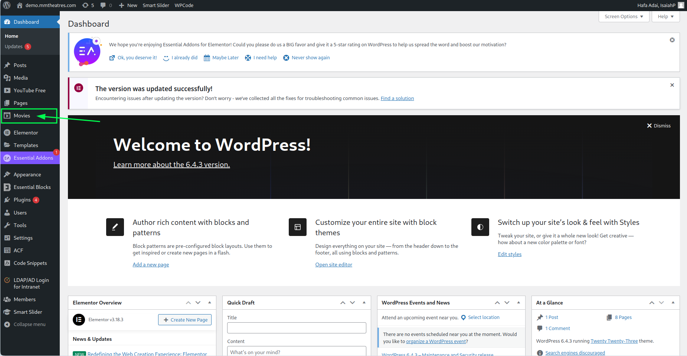

# Navigating to Movie Posts

If the image below can’t be seen, place the cursor in the dark gray sidebar and scroll up until the words dashboard appears. Search for it and if still can’t be fount, scroll down and repeat.

If it still appears to be lost, contact the admin as you might not have privilege to access it with the role assign to you.

## Movies Can’t Be Found

What the movie post looks like

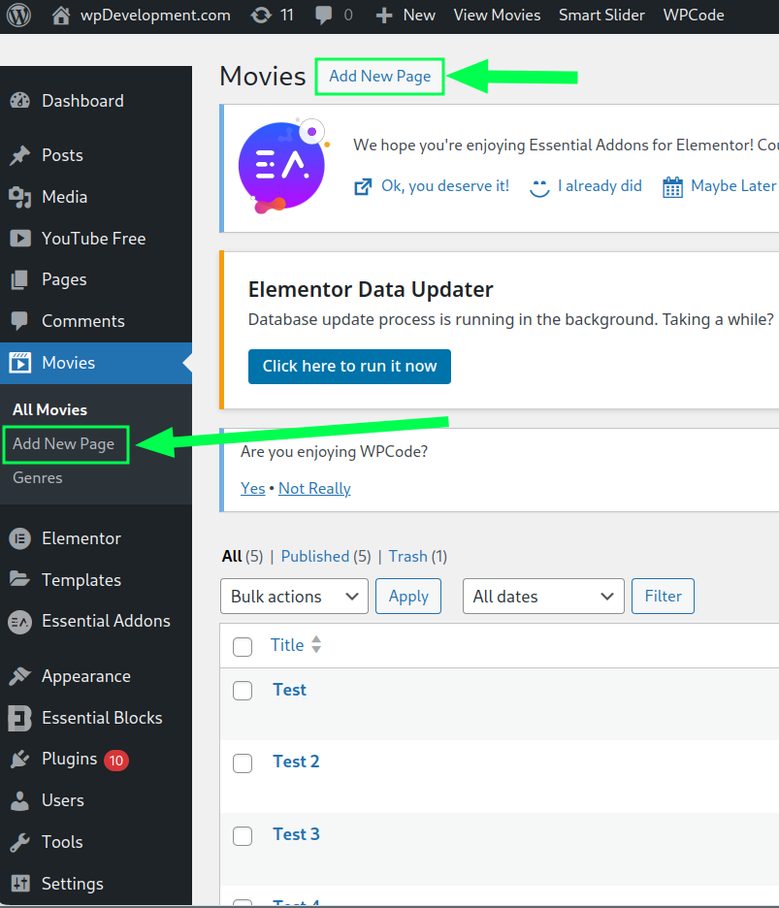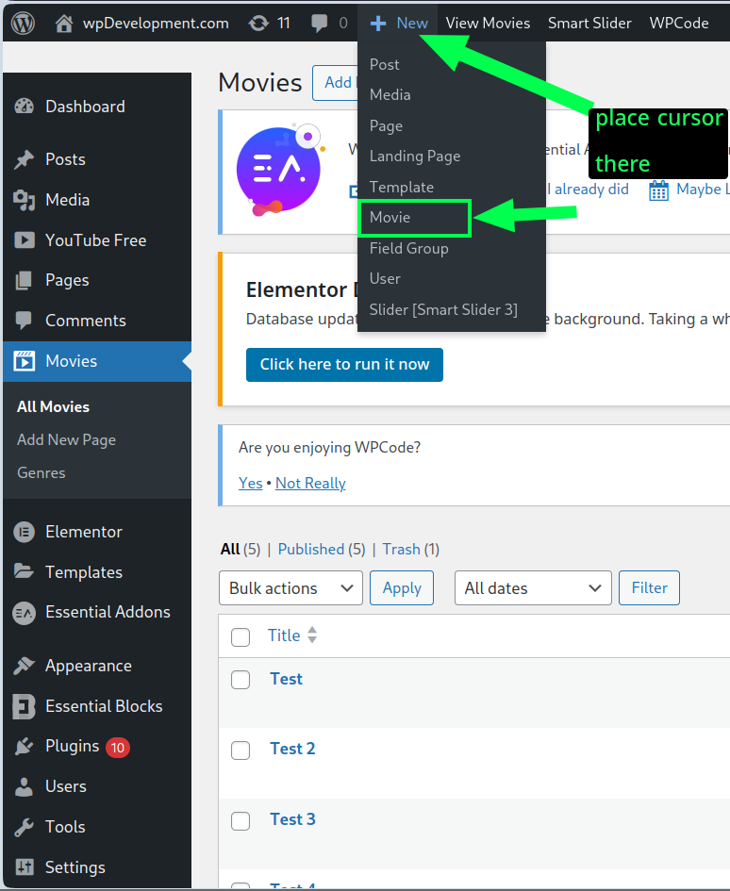

# Add New Movie

There are three ways to add movies. The first two as show on

the top right of this page, requires you to navigate to movies.

The third method allows you to add a new movie from anywhere.

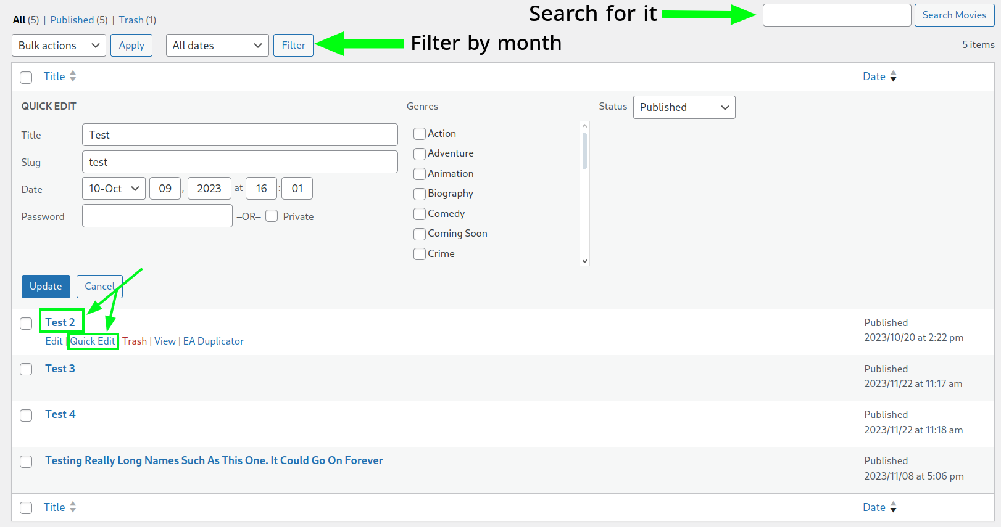

# Edit Movie Post

Click the title or hover click quick edit

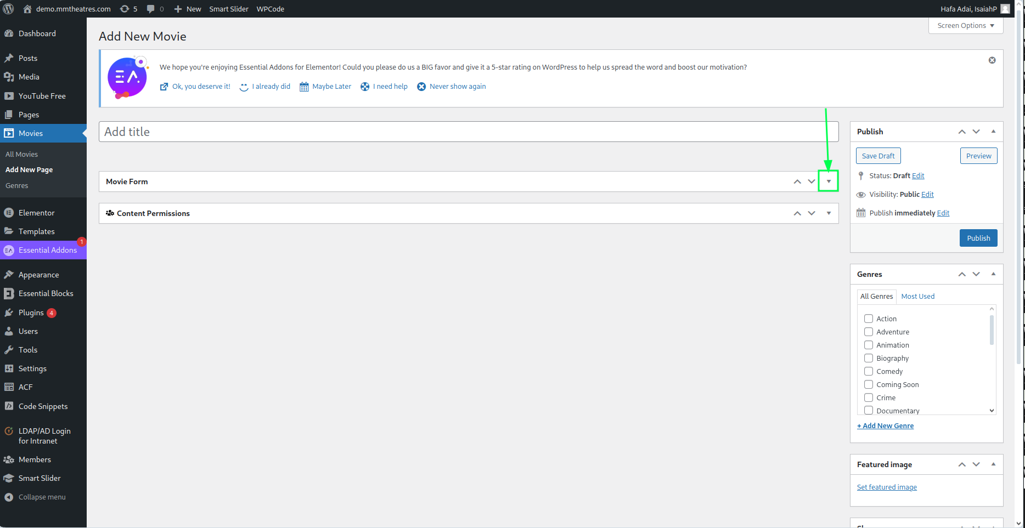

# Fill Out Movie Form 1 of 2

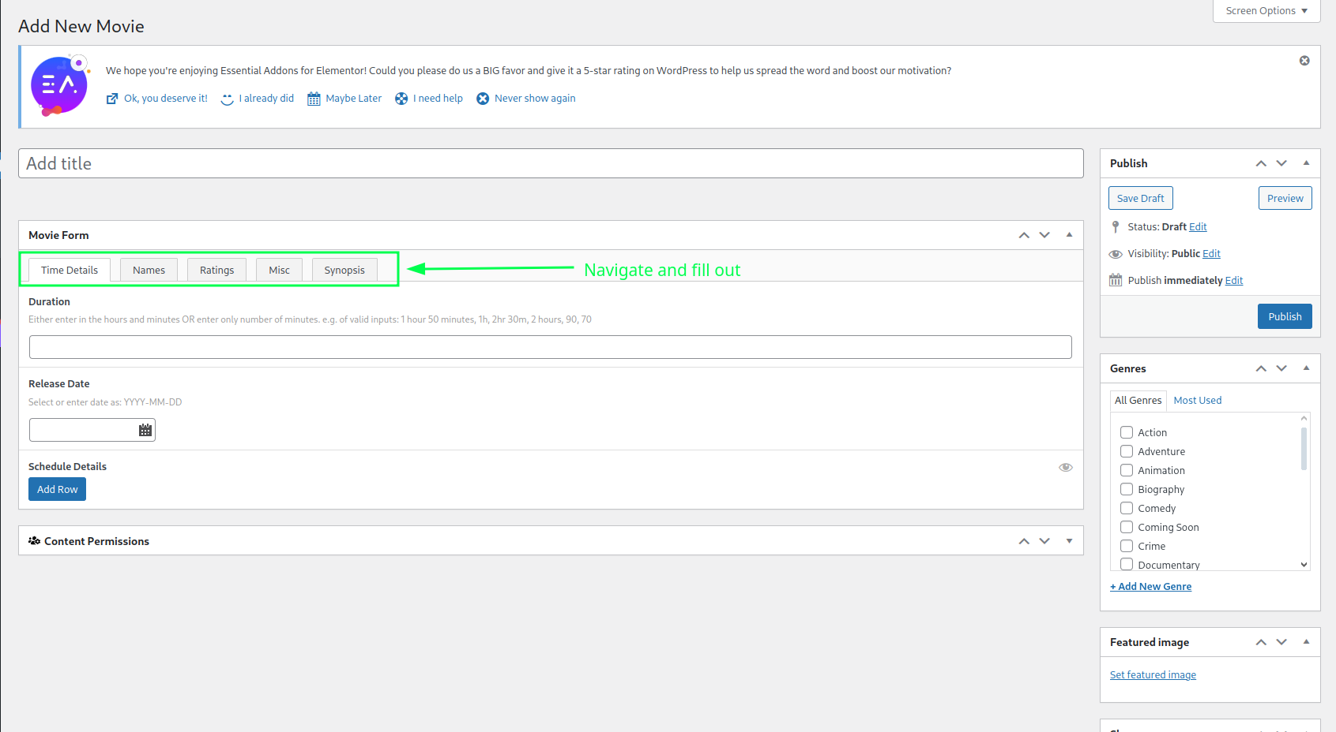

# Fill Out Movie Form 2 of 2

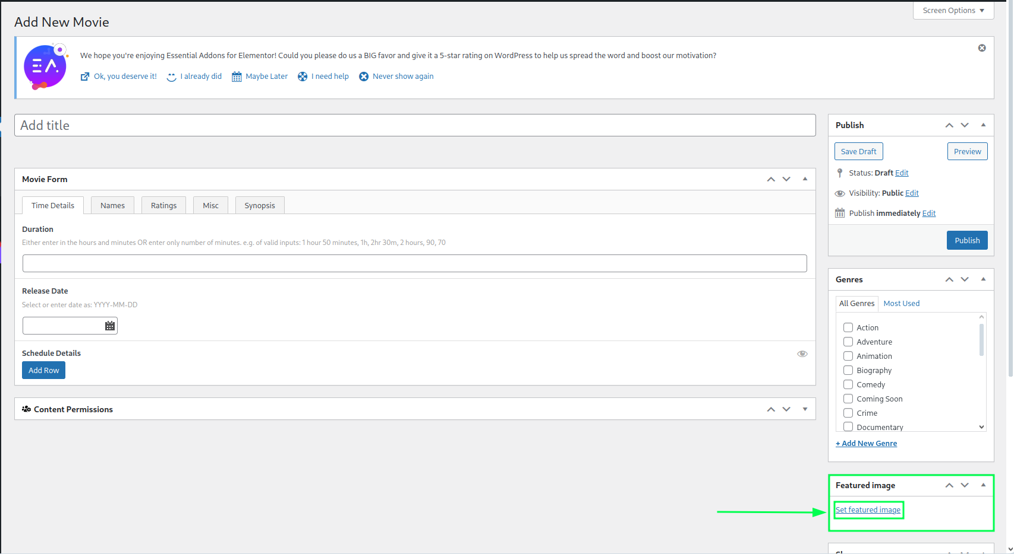

# Add Featured Image 1 of 2

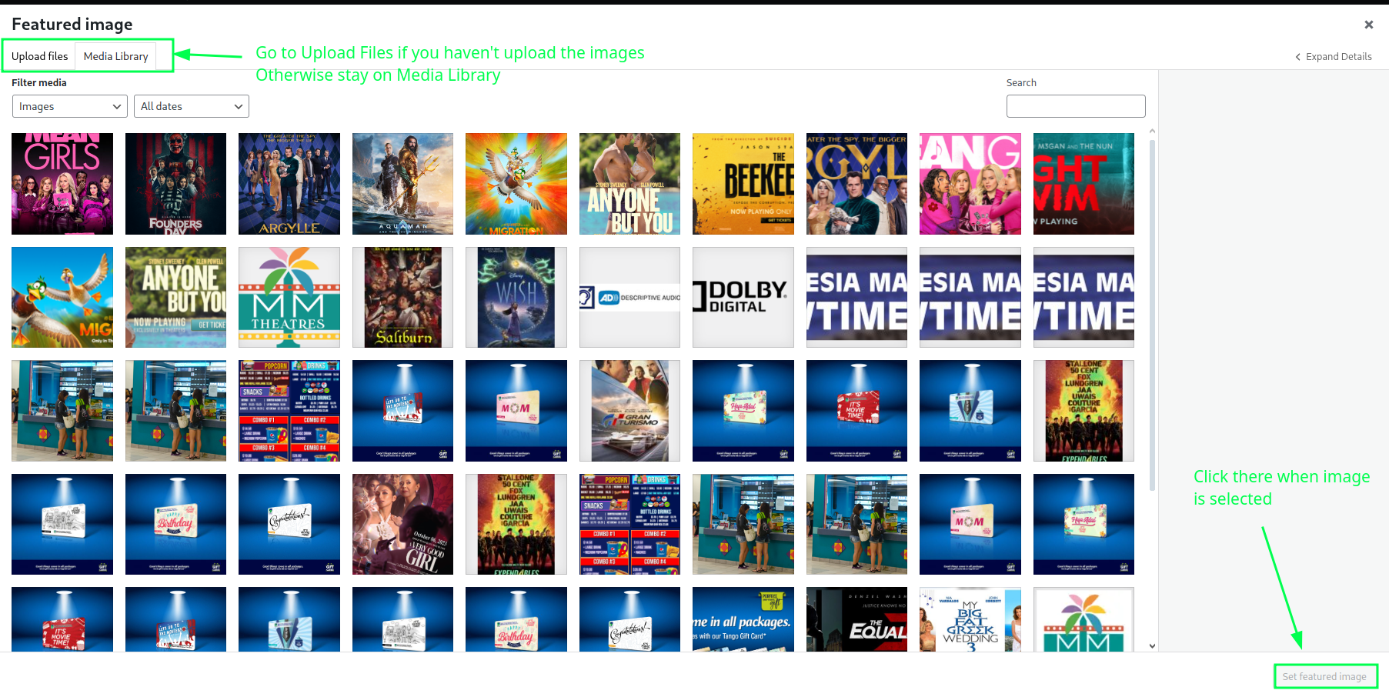

# Add Featured Image 2 of 2

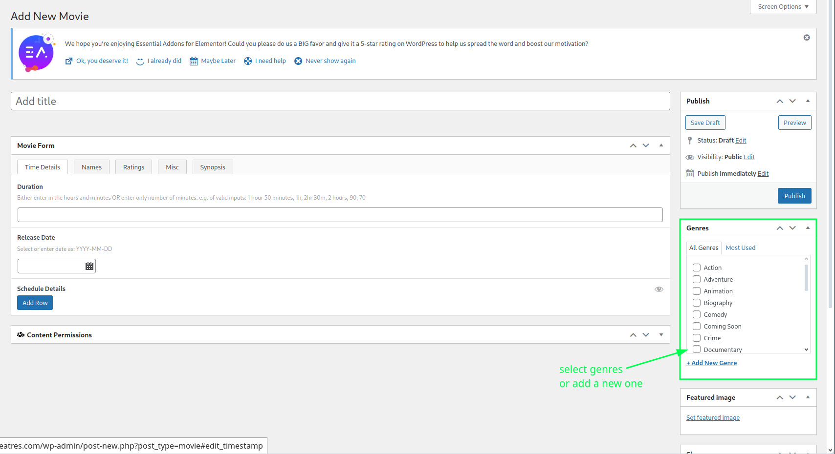

# Select Genres

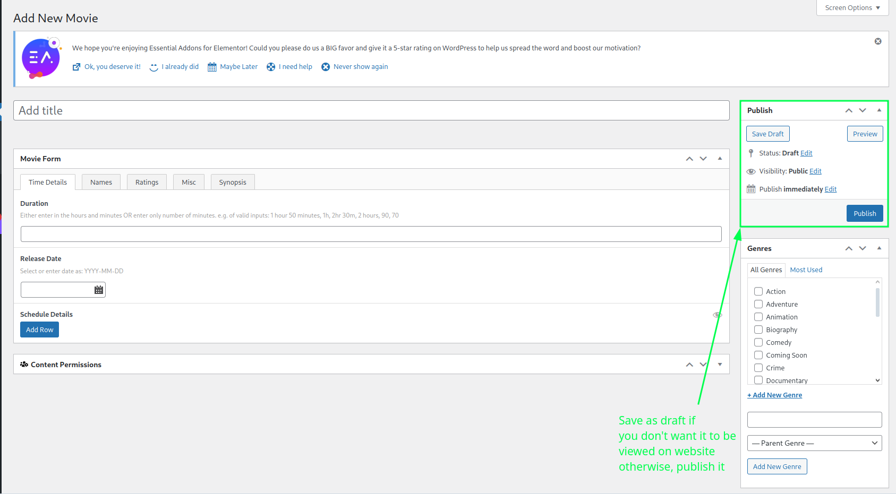

# Publish or Save